**MSc in Computing (Enterprise Software Systems)**

**User Experience & Design**

Assignment 1 – Business Card

Vibin Varghese

**(Student Id: 20096057)**

*Submitted Date*

20th February 2022

* **Design Summary**

As a person, I am very passionate about films; mainly superhero action movies of DC and MARVEL. Most of these films gave me excitement and powerful actions feel great while watching.

Word I have selected for the assignment is **Excitement.**

* **Chosen Approach**

1. ***Color***

As per the [Color emotion guide](https://medium.com/marketing-and-entrepreneurship/the-psychology-of-logo-color-in-how-consumers-view-your-brand-d3afe84f2bdb), Red color shows excitement, energy, love, danger, action, and so on. I have chosen the color red as the primary color for the design for the same reason. White, blue, and gray are some colors that work with the primary color red. Shades of blue show strength, also blue works well with the primary color red, as per the source. An adjacent color schema of red is used in the business card. [Paletton.com](https://paletton.com/) is used to get the color code for the schema.

Color schema: Adjacent = Analogous

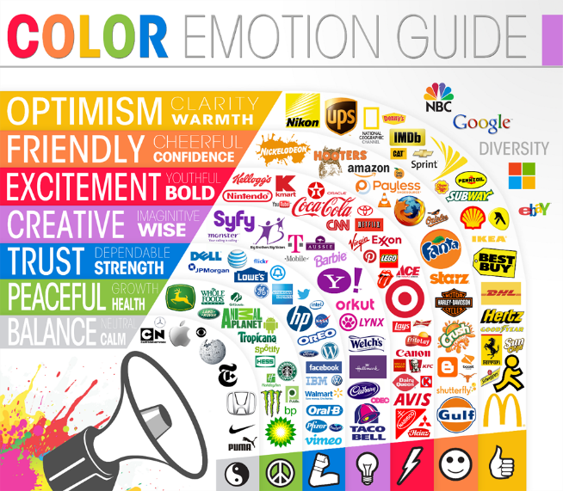In the aspect of the business card, A red-black combination of the business card will help to get remembered easily. Highlight the company name and name into the two different color matches with the business card theme.

Ref:

* [https://medium.com/the-psychology-of-color](https://medium.com/marketing-and-entrepreneurship/the-psychology-of-logo-color-in-how-consumers-view-your-brand-d3afe84f2bdb)
* <https://www.bhg.com.au/colours-that-go-with-red>
* [https://paletton.com/](https://paletton.com/" \l "uid=55B0u0klclNa02rU4o72p8LvQUo" \o "https://paletton.com/)
* [https://verywellmind.com/color-psychology](https://www.verywellmind.com/color-psychology-2795824)
* <https://bhg.com.au/colours-that-go-with-red>
* [https://smashingmagazine.com/color-theory-for-designers/](https://www.smashingmagazine.com/2010/01/color-theory-for-designers-part-1-the-meaning-of-color/" \o "https://www.smashingmagazine.com/color-theory-for-designers)
* <https://fifteendesign.co.uk/blog/colour-psychology-design/>

1. ***TypeFace***

Sans serif fonts are the best choices for business cards. They also work well on digital displays when you’re designing business cards an online app or using desktop publishing software. On lower-resolution displays, fine details like serifs can disappear or appear too large. I have used, **Trebuchet MS** font, which is a humanist sans-serif typeface for the name and designation in the business card. For other details, I have used the **Arial Rounded** font. Arial (sans-serif) Typeface contains more humanist characteristics than many of its predecessors and as such is more in tune with the mood of the last decades of the twentieth century.

Sans-serif fonts are typefaces that do not have serifs on the ends of their letterforms. They are considered more modern and minimalist and are known for their high legibility. These fonts lack additional flourishes and have a more orderly and clean appearance.

Ref:

* <https://www.masterclass.com/articles/serif-vs-sans-serif-compared>
* <https://www.vistaprint.com/hub/best-fonts-for-business-cards>

1. ***Graphic Design (Lines and Shape)***

I have chosen geometric Lines and shapes. Triangle type shapes are used in the business card. Triangles give a sense of movement. They are associated with direction, power, movement, action, and excitement.

Thin Line is given to separate the address and contact. The thin line represents elegance, modesty, also to show a very small difference between two things that may seem different; In this business card, just to differentiate the address and contact

Ref:

* **Book** : Contrast: Intro to Designing Beyond Form and Function By Jeremy Skoog, Page 50
* <https://www.vectornator.io/blog/geometric-patterns>
* <https://vanseodesign.com/web-design/visual-grammar-lines/>

1. ***Alignment and Proximity***

All the text on the business card is left aligned. Visual alignment is more important than precise alignment, keep in mind this statement; the text is Aligned left, which allows me to set the logo on the right.

I have also grouped the contact in a section below and the company name address in the top position, leaving the white space in between. Grouping is done based on the information required to contact through phone or digitally.

1. ***Logo***

The concept I have used to create a logo is Monogram logos or lettermarks. These are logos that consist of letters, The lettermark is all about simplicity. By utilizing just a few letters lettermark logos are effective at streamlining any company brand if they have a long name. From the name Vibin and UX design, I have combined V and X. Font used for logo – Konexy.



1. ***Final Business Card***

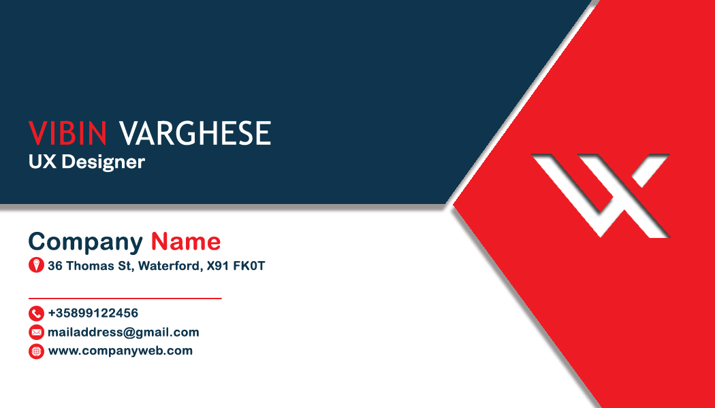

1. ***Design Sketch***

